Gray information for article formatting is for guidance only.
Please remove them before submitting.
Title of the article in the original language
(16 pts – Arial – bold – centralized – low case)
Title of the article in Portuguese
(14 pts – Arial – centralized – low case)
Title of the article in English
(14 pts – Arial – centralized – low case)

ABSTRACT (12 pts – Arial – bold – justified)
Elaborate an abstract in the language in which the article was written, containing 150 to 250 words, based on NBR 6028. The abstract should not be written in the first person and should contain the thematic focus, objective, method, results and work conclusions. (12 pts – Arial – justified)
Keywords: First word; Second word; Third word.
(12 pts – Arial – negrito – justified)

RESUMO (12 pts – Arial – bold – justified)
Elaborate an abstract, in portuguese, containing 150 to 250 words, based on NBR 6028. The abstract should not be written in the first person and should contain the thematic focus, objective, method, results and work conclusions. (12 pts – Arial – justified)
Keywords: First word; Second word; Third word.
(12 pts – Arial – justified)

ABSTRACT (12 pts – Arial – bold – justified)
Elaborate an abstract, in english, if the article is written in Spanish, Italian, French or German, containing 150 to 250 words, based on NBR 6028. The abstract should not be written in the first person and should contain the thematic focus, objective, method, results and work conclusions. (12 pts – Arial – justified)
Keywords: First word; Second word; Third word.
(12 pts – Arial – negrito – justified)
Primary Sections (14 pts – Arial – bold – justified)
The texts of the articles should have an extension between 4500 and 7000 words, not counting the abstracts references. The review texts should have about 1500 to 2000 words. Text must be set to Arial font, 12 pts, justified, with automatic spacing after paragraphs, and space of one line between paragraphs and section headings/subheadings. Foreign words, or highlighted by the author, should be written in italics. Do not use italic and quotation marks together to highlight snippets/words.
In paraphrases which the authorship of the source is not part of the text, refer to it as follows: lorem ipsum dolor sit amet, consectetur adipiscing elit. Ut vulputate tincidunt turpis at tincidunt. Suspendisse aliquam venenatis ipsum (FREIRE, 2012).
The citations should follow NBR 10520. Short direct quotes (up to three lines) should be enclosed in double quotation marks, "[...] lorem ipsum dolor sit amet, consectetur adipiscing elit. Ut vulputate tincidunt turpis at tincidunt. Suspendisse aliquam venenatis ipsum", preceded or followed by reference to the source, in accordance with the above rule, together with the page (s) from which they were withdrawn.
In case of long quotations:
Example of a long quotation, consisting of more than three lines. The text must be set to Arial, 10 pts, justified, single spacing, with a 4cm indent throughout the paragraph. Lorem ipsum dolor sit amet, consectetur adipiscing elit. Ut vulputate tincidunt turpis at tincidunt (FREIRE, 2010, p. 95).
Secundary Sections (12 pts – Arial – bold – justified)
Text must be set to Arial font, 12 pts, justified, with automatic spacing after paragraphs, and space of one line between paragraphs and section headings/subheadings. Foreign words, or highlighted by the author, should be written in italics. Do not use italic and quotation marks together to highlight snippets/words. End-of-text notes should be inserted next to the text, for some explanatory information, not to exceed the use of 200 words in each note.
Figures should be attached next to template, in JPEG format. Tables or frames should be elaborated using the word tables tool itself, with adequate dimensions.

(10 pts – Arial – centralized)
Figure 1 – Example of figure
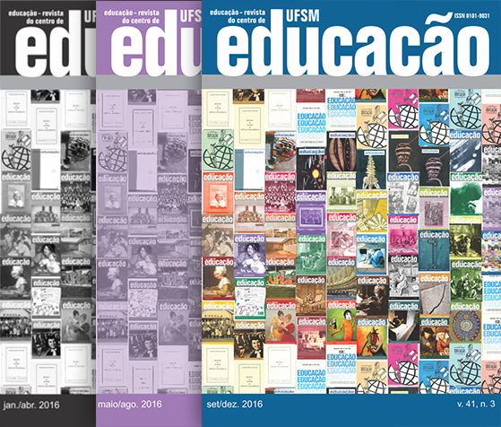
Source: Figure source. (10 pts – Arial – centralized)
Table 1 - Table title (10 pts – Arial – justified)
TITLE EXAMPLE | TITLE EXAMPLE
Information X | Information X
Information X | Information X
Information X | Information X
TOTAL | Information X
Source: Table Source. (10 pts – Arial – justified)
Frame 1 – Frame title (10 pts – Arial – justified)
TITLE | TITLE | TITLE
Information X | Information X | Information X
Information X | Information X | Information X
Information X | Information X | Information X
Source: Frame Source. (10 pts – Arial – justified)
References (14 pts – Arial – bold – left aligned)
Text setting: 12 pts, Arial, left alignment, automatic spacing between each reference. Authors' first and last names should be written in length, and repeated, instead of dash/dot use (______.).
All examples presented here are fictitious.
– Personal Author
LAST SURNAME (Uppercase), Name and surnames. Title. 2. ed. (Number of edition) Place: Publisher, year.
– Up to 3 authors
SILVA, Emanuel Tavares; GOMES, Galvão Vieira; SOUZA, Maria Nunes. Title. 13. ed. rev. and enl. Place: Publisher, year.
– More than 3 authors
SILVA, Emanuel Tavares et al. Title: subtitle. Place: Publisher, year. capítulo de obra
– Organizer(s), coordinator(s), translator(s)
SILVA, Emanuel Tavares; GOMES, Galvão Vieira (Orgs.). Title: subtitle. Translation of Name and Surname. [Sl: sn] (If the referenced opus do not contain local and publisher), year.
– Author entity
BRAZIL. Ministry of Education. Title. Brasília, DF, year.
– Author unknown
FIRST word of the title. Place: Publisher, year.
– Parts/Chapter of work
SILVA, Emanuel Tavares. Title of the piece. In: SOUZA, Maria Nunes. Title of publication. Place: Publisher, year, p. 3-9.
SILVA, Emanuel Tavares. Title of the piece. In: SILVA, Emanuel Tavares (even if the author of the part is equal to that of the publication in the whole). Title of publication. Place: Publisher, year, p. 3-9.
– Monographs and parts of monographs in electronic media and online
SILVA, Emanuel Tavares. Title. Place: Publisher, year. 1 CD-ROM.
SANTA MARIA. In: ENCYCLOPEDIA virtual of municipalities in RS. Place: Publisher, year. CD-ROM 1.
SILVA, Emanuel Tavares. Title. [S.l.]: Publisher, year. Available at: <http://www.ufsm.br>. Accessed: 3 January 2000.
Entry. In: DICTIONARY of foreign languages. Place: Publisher, year. Available at: <http://www.url complete>. Accessed: 3 January 2000.
– Events (papers presented)
SILVA, Emanuel Tavares; GOMES, Galvão Vieira. Title. In: NAME OF EVENT IN UPPERCASE, 1. (Numbering of the event, if any), year, local (of the event). Annals ... (Follow this model for Abstracts...) Local (publication): Publisher, year, p. 3-9. (When it is in electronic media, add the physical description of the resource used after pagination. E.g. ... p. 3-9. 1 CD-ROM.)
– Events (papers presented) online
SILVA, Emanuel Tavares. GOMES, Galvão Vieira. Title. In: NAME OF EVENT IN UPPERCASE, 1. (Numbering of the event, if any), year, local (of the event). Annals electronic ... Place: Publisher, year. Available at: <http://www.url complete>. Accessed: 3 January 2000.
– Articles and/or matter Journal
SILVA, Emanuel Tavares. Title of the article. Title of the Journal, local, n. 1 (publication number), p. 3-9 (pagination initial and final), jan. 2000 (date of publication).
– Articles Online
SILVA, Emanuel Tavares. Title of the article. Title of the Journal, Local, numbering, jan. 2000 (date of publication). Available at: <http://www.url complete>. Accessed: 3 jan. 2000.

Example of footnote. (10 pts – Arial – justified)

