Universidade Federal de Santa Maria
REGET, v. 25, e4, 2021
DOI: 10.5902/2236117055350
ISSN 2236-1170
Recebido: 25/09/2020 • Aceito: 29/12/2020 • Publicado: 22/03/2021


Environmental Technology
Canola oil as an alternative quenchant for the AISI 8640 steel
Óleo de canola como uma alternativa para a têmpera do aço AISI 8640
Leonardo Pratavieira Deo^{I}
Artur Mariano de Sousa Malafaia^{II}
^{I} Professor Doctor at Engineering Department, Federal University of Lavras, Lavras – MG, Brazil. E-mail: leonardo.deo@ufla.br

^{II} Professor Doctor at Department of Mechanical and Industrial Engineering, Federal University of São João del-Rei, São João del-Rei – MG, Brazil. E-mail: arturmalafaia@ufsj.edu.br

ABSTRACT
AISI 8640 is one of the most used steel in the manufacturing industry due its wide range of applicability and properties. The quenching process is commonly applied in parts made of this steel in order to enhance some properties, such as strength and hardness. Petroleum derived oils are the most common quenchants, however this kind of quenchant is considered to be non-biodegradable, toxic to the health and environment, as well as, not renewable. In the present study, canola oil presented the same efficiency than a conventional petroleum derived oil in the quenching process of AISI 8640 steel billets with diameter of 25.4mm.
Keywords: Microstructure; Phase transformation; AISI 8640 steel; Canola oil; Quenching
RESUMO
O AISI 8640 é um dos aços mais utilizados na indústria de manufatura devido às suas grandes faixas de aplicabilidade e propriedades. O processo de têmpera é comumente aplicado em peças feitas desse aço com o objetivo de melhorar suas propriedades, como a resistência e a dureza. Óleos derivados de petróleo são os mais comumente utilizados como meio de têmpera, porém esse tipo de óleos é considerado como não biodegradável, tóxico para a saúde e o ambiente, bem como, não renováveis. No presente estudo, o óleo de canola apresentou a mesma eficiência que o óleo convencional derivado de petróleo em um processo de têmpera de tarugos de aço AISI 8640 com diâmetro de 25,4 mm.
Palavras-chave: Microestrutura; Transformação de fases; Aço AISI 8640; Óleo de Canola; Têmpera

1 INTRODUCTION
Steels are widely used on many applications and some of them require heat treatments in order to achieve the desired properties (CASEIRO; OLIVEIRA; ANDRADE-CAMPOS, 2011). The steel AISI 8640 is one of the most used in the manufacturing industry for production of gears, shafts, crankshafts, pistons, etc. This wide range of applicability is possible because of its excellent temperability which provides high strengths (SILVEIRA et al., 2018).⁠
During quenching process, hardenable steels, such as SAE 8640, may suffer dramatic changes in their microstructure and, consequently, on their properties (BARROQUEIRO et al., 2016).⁠ Martensite is the responsible microstructure for the high-strength hardness and its formation is obtained by the austenite phase generation followed by a rapid quench in a quenchant (KRAUSS, 1999).⁠ In industrial applications, cold water is the most common quenchant, however this practice is associated with brittle tendencies in the steels. An alternative way to minimize these brittleness problems is the use of petroleum derived oils as quenchants. In general, the petroleum derived oils are the best options to be used as quenchants, once they present lower quench severity values (Grossman hardenability – H), as well as, lower cooling rates then cold water (SIMENCIO OTERO et al., 2017).⁠ As a result of petroleum derived quenchants use, the quenched steels present lower residual stress, and consequently the chance of failure during some application also is lower. Despite of the great performance in steel quenching, petroleum oils are broadly considered to be non-biodegradable, toxic to the health and environment, as well as, not renewable (EL-KINAWY; EL-HAMIDI; ABDALLAH, 2013).⁠ In this context, vegetable oils are of interest as alternatives to petroleum oils for industrial oil base stock and fuel use because of various technical properties, biodegradability and general non-toxicity and therefore are considered to be “environmentally friendly” (SIMENCIO OTERO et al., 2017). In addition, vegetable oils are relatively easier to be produced, as well as, they can be disposed of properly in a better ecological manner compared to the petroleum derived oils (ŠMAK; VOTAVA; POLCAR, 2020).
Measurements of heat transfer during quenching, comparing canola and petroleum derived oils demonstrated that they present different heat extraction dynamic, with faster initial reaction for petroleum derived oil and faster cooling rate subsequently for the canola oil. However, the temperature gradient after 100 s is similar for both oils (MATIJEVIC et al., 2019). Furthermore, comparing the quenching performance of different vegetable and mineral oils in the AISI 1045, it was found that canola oil presented the best hardening effect (PÉREZ; FRYE; LLANO, 2019). Similar result was observed for AISI 4340, with soybean and sunflower oils achieving the same hardenability than mineral oil (BRITO et al., 2019). Some properties of canola oil and a petroleum-based oil were compared (MATIJEVIC et al., 2019) and are presented in Table 1.
Table 1 – Physical properties of canola oil and Kalenol 32 (adapted from MATIJEVIC et al., 2019)
Property | Canola oil | Kalenol 32
Viscosity, 40 °C, mm²/s | 35.14 | 32
Viscosity, 100 °C, mm²/s | 8.7 | 5.4
Density 15 °C, g/mL | 0.9201 | 0.863
Open cup flash point, °C | 300 | 225
Pour point, °C | -24 | -15
Source: Authors (2020)
In the present study, canola oil and a conventional petroleum derived oil were used in the quenching process of AISI 8640 steel samples. Micrograph and hardness analysis of the quenched samples were made in order to compare the quench efficiency of both quenchants and some equivalence was found.
2 METHODOLOGY
2.1 Annealing
Two cylindrical billets made of AISI 8640 steel with diameter of 25.4 mm were used. The samples were annealed in a preheated oven at 830 °C (around 50 °C above the upper critical temperature, A3) (CHANDLER, 1995).⁠ The samples were held into the oven for 1 hour and then, they were slowly cooled inside the oven. After annealing process, cross sections of both samples were removed with a cutting machine in order to evaluate the efficiency of the annealing process by metallography and hardness measurements.
2.2 Quenching
The samples, without the removed cross sections, were heated again 50 °C above A3 during 1 hour; one of them was abruptly cooled in canola oil and the other one was abruptly cooled in a conventional petroleum derived oil called “ALL TEMPERA 32”. According to the authors searching in the local market, in January 2021, the canola oil costs around 1.90 $/L, while a conventional quenchant costs around 4.70 $/L. In addition, properties of canola oil and a similar petroleum-based oil, with the same viscosity, were presented in Table 1. After the quenching process, cross sections of both samples were cut with the cutting machine in order to evaluate the quenching efficiency.
2.3 Metallography
The cross sections of annealed and quenched samples were cold mounted with a polymeric resin, sanded and polished. Sandpapers between 100 and 2000 mesh, as well as, alumina abrasive with granulometry of 1 micron were used in the sanding and polishing processes respectively. After the polishing process, the samples were exposed to the Nital 3% solution for 5 seconds to reveal the microstructures and they were examined in a light microscope OLYMPUS BX51. For each sample, images from surface, ¼, ½ and centre of the radius were taken to evaluate the homogeneity of annealing and quenching processes.
2.4 Rockwell Hardness Test
The scales used were Rockwell B to the annealed samples (softer) and Rockwell C to the quenched samples (harder). The hardness measurements were taken in the same points of micrographs.
3 RESULTS AND DISCUSSIONS
Fig. 1 shows the microstructure of one annealed sample and two microconstituents are present in this micrograph; the lighter regions correspond to the proeutectoid ferrite and the darker regions correspond to the pearlite.
Figure 1 – Microstructure observed over the entire cross section of an annealed specimen
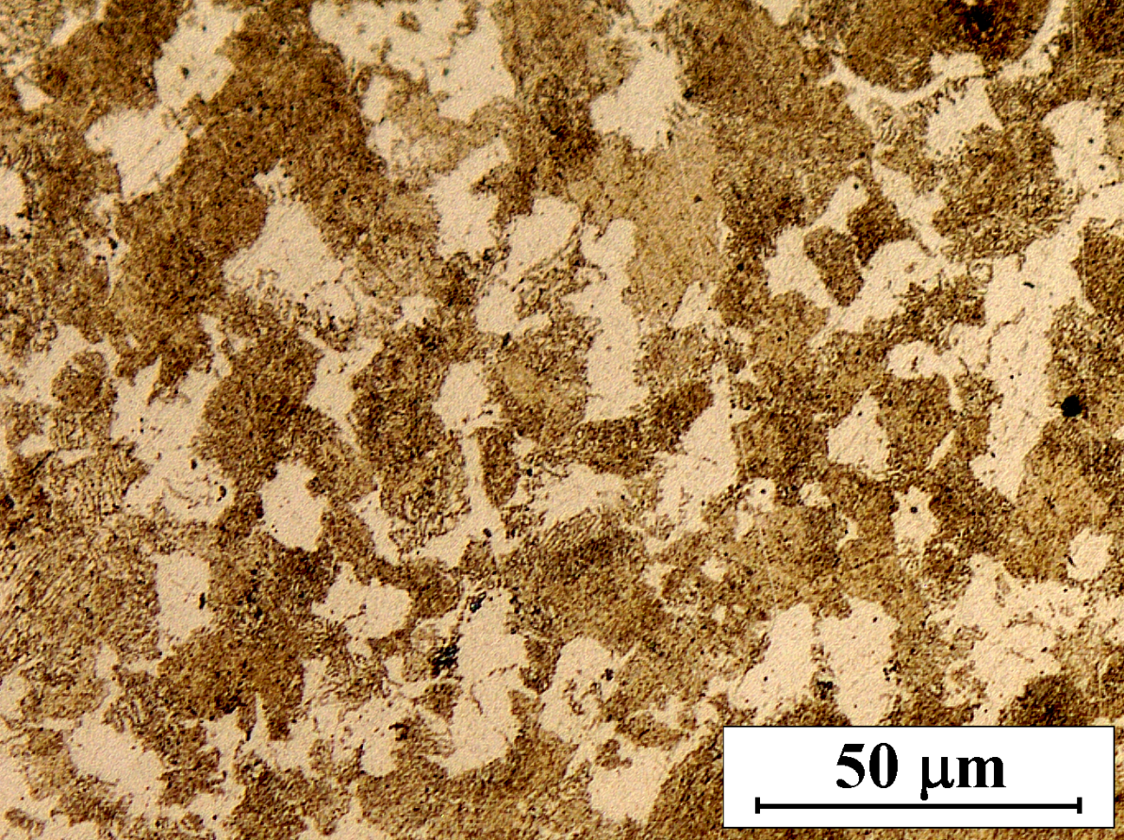
Source: Authors (2020)
The pearlitic microstructure consists of alternating lamellae of ferrite and cementite (Fe3C), that form simultaneously during the phase transformation from the austenitic region (CALLISTER JR.; RETHWISCH, 2012).⁠ The pearlite usually exists as colonies and within each colony the lamellae are oriented in essentially the same direction, which varies from one colony to another. The thick light layers are the ferrite phase, and the cementite phase appears as thin lamellae, most of which appear dark. Many cementite layers are so thin that adjacent phase boundaries are so close together and they are unresolved at low magnifications as seen in the micrograph showed in Fig. 1, therefore the pearlite appears dark. Mechanically, pearlite has properties intermediate between those of the soft, ductile ferrite and the hard, brittle cementite (IACOVIELLO et al., 2014).⁠
Figures 2 and 3 are representative of those microstructures obtained for the quenching processes, where martensite is the predominant microstructure. These micrographs show the martensitic microstructures in different positions over the cross section of the quenched cylinders in mineral and vegetable oils respectively. No visible reduction of the martensite amount is evident with the distance from the surface. The hardness values are shown in Table 2 and they correspond to the same points where the micrographs were taken. Each hardness value reported in Table 2 is the average of three measurements obtained at the same distance from the center. Regarding annealed condition, the values obtained where exactly the same in all positions. For the quenched samples, the hardness values are very close to each other and it confirms the samples were completely through-quenched. In addition, the samples quenched in the different coolants do not significantly differ in the hardness values. The range of values, between 51.0 and 53.3 HRC, are typically related to martensitic microstructure for the AISI 8640 steel (CHANDLER, 1995), as also observed using 4 different mineral oils previously, with values between 51.5 and 54 HRC (DAS GUPTA, 1949). Medium carbon hardened steels normally pass by a tempering process after quenching, and for the similar AISI 4340 steel, the typical hardness values after tempering are between 44 and 48 HRC (SEQUEIRA et al., 2007). Thus, the hardness values obtained in the present investigation suggest the possibility of an adequate tempering process in order to achieve typical hardness values for applications of AISI 8640 steel parts.
Figure 2 – Microstructure of the cylinder quenched in the petroleum derived oil in different positions of the cross section: (A) surface, (B) ¼, (C) ½ and (D) centre of the radius on the analyzed surface
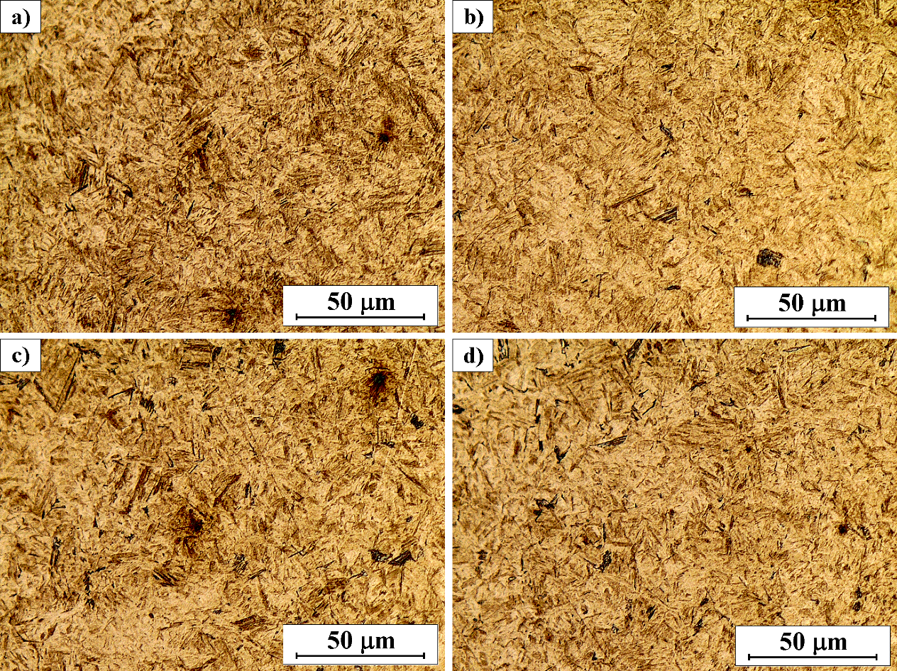
Source: Authors (2020)
Figure 3 – Microstructure of the sample quenched in the canola oil in different positions of the cross section: (A) surface, (B) ¼, (C) ½ and (D) centre of the radius on the analyzed surface
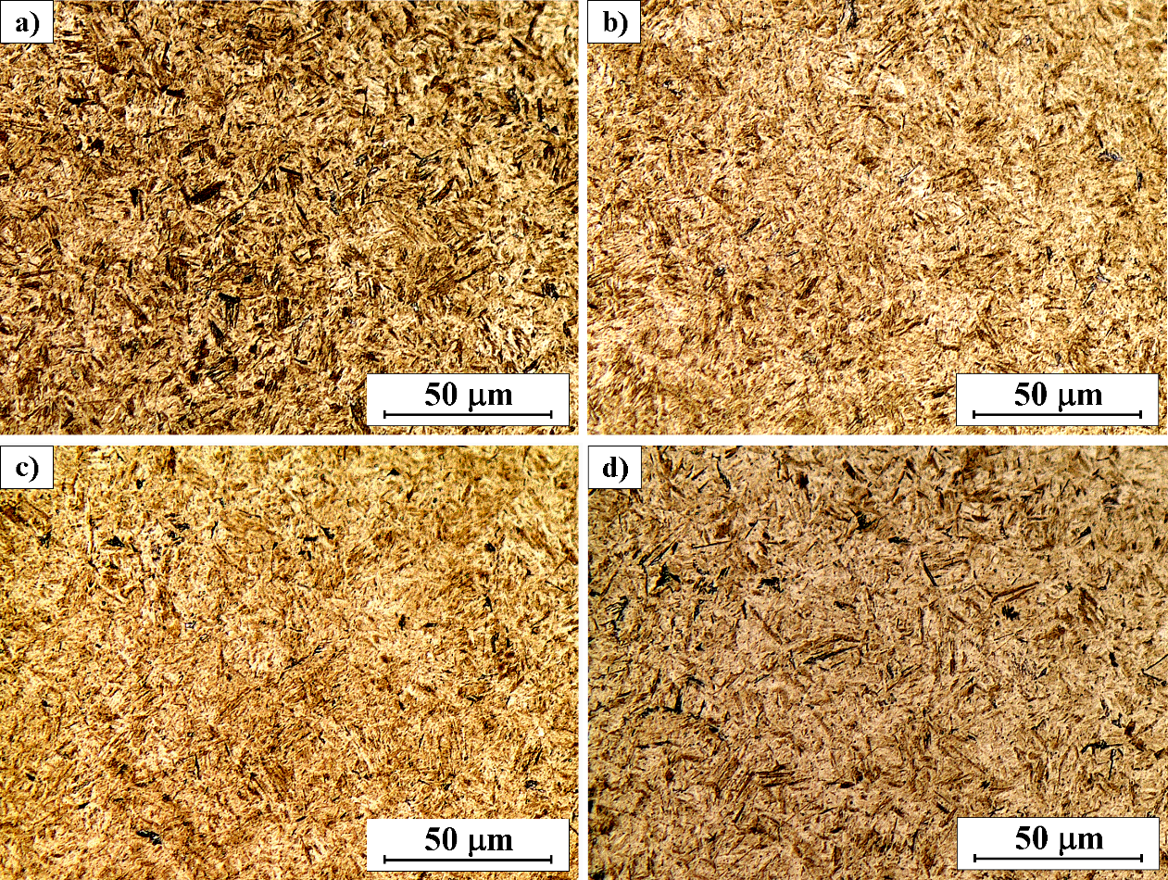
Source: Authors (2020)
Table 2 − Hardness values of the AISI 8640 cylindrical specimens with diameter of 25.4 mm
Heat treatment | Surface | ¼ Radius | ½ Radius | Centre
Annealed (HRB) | 90.2 ± 1.3 | 90.2 ± 1.3 | 90.2 ± 1.3 | 90.2 ± 1.3
quenched in petroleum derived oil (HRC) | 52.0 ± 1.1 | 52.6 ± 0.7 | 52.8 ± 0.9 | 53.3 ± 0.9
quenched in canola oil (HRC) | 51.0 ± 2.1 | 52.5 ± 0.6 | 52.7 ± 0.8 | 53.3 ± 2.0
Source: Authors (2020)
Martensite is a non-equilibrium single-phase with a body-centered tetragonal (BCT) crystalline structure that results from a diffusionless transformation of austenite (CALLISTER JR.; RETHWISCH, 2012).⁠ In low and medium high-strength hardened steels, such as AISI 8640, the martensitic microstructure is called lath and it consists of parallel block and packet crystalline structures. Because of the largely common crystallographic orientation of the laths, the martensite becomes an effective grain structure with deformation control. The deformation is accomplished by twinning and limited dislocation motion, providing high strength and hardness in martensitic ferrous alloys (KRAUSS, 1999).⁠
From all measurements obtained at the same distances from the center (Figures 2 and 3, as well Table 2), the quench severity in petroleum derived oil and in canola oil are comparable. Our results suggest the vegetable oil has the same efficiency than the petroleum derived oil in cylindrical specimens made of AISI 8640 steel with diameter until 25.4 mm. Consequently, the canola oil can be considered as a potential substitute for the conventional petroleum derived oil “ALL TEMPERA 32” in the quenching process for SAE 8640 steel parts thinner than 25.4 mm.
The use of vegetable oils rather than petroleum derived oils exhibits several advantages in industrial applications, such as: (1) Most of the petroleum derived oils are toxic to the environment, and often this kind of product is difficult to dispose of after use. Vegetable oils are typically much more biodegradable and less persistent when released to the environment via the soil and groundwater (SIMENCIO OTERO et al., 2017). (2) Some countries have laws which inhibit or prevent the use of petroleum lubricants and quenchants, thus the use of ecofriendly oils in certain applications is required. (3) Vegetable oils are renewable and therefore provide the possibility of contributing toward the goal of energy independence and security (ERHAN; SHARMA; PEREZ, 2006). (4) Price of vegetable oil are reduced compared to mineral ones used for quenching (BRITO et al., 2019).
CONCLUSIONS
The micrographs show that there is no significant reduction of the martensite amount with the distance from the surface in both samples quenched in the different coolants. In addition, the hardness measurements confirm that the samples were completely through-quenched once the hardness values are very close to each other.
Our results evidence that canola oil has the same efficiency than the petroleum derived oil “ALL TEMPERA 32” in the quenching of cylindrical specimens made of AISI 8640 steel with diameter of 25.4 mm or thinner, achieving Rockwell C Hardness higher than 50 in the whole specimen thickness. Consequently, this vegetable oil can be considered as a potential substitute for this mineral oil in the quenching process for AISI 8640 steel parts equal or thinner than 25.4 mm. Furthermore, this substitution can reduce health and environmental damage in addition to the use of a renewable oils for steels heat treatment, allowing also cost reduction.
ACKNOWLEDGEMENTS
The authors would like to thank Grupo Maciel, a local manufacturing company, for the steel billets donation, a study group from Federal University of Lavras named G-Óleo for the production and donation of canola oil, as well as, All Indústria de Lubrificantes Ltda, a regional lubricant producer for the petroleum derived oil donation.
REFERENCES
BARROQUEIRO, B.; DIAS-DE-OLIVEIRA, J.; PINHO-DA-CRUZ, J.; ANDRADE-CAMPOS, A. Multiscale analysis of heat treatments in steels: Theory and practice. Finite Elem. Anal. Des. 2016;114:39–56.
BRITO, P.; RAMOS, P. A.; RESENDE, L. P.; DE FARIA, D. A.; RIBAS, O. K. Experimental investigation of cooling behavior and residual stresses for quenching with vegetable oils at different bath temperatures. J. Clean. Prod. 2019;216:230–238.
CALLISTER JR., W. D.; RETHWISCH, D. G. Ciência Engenharia de Materiais - Uma Introdução. 8a ed. Brasil: LTC, 2012.
CASEIRO, J. F.; OLIVEIRA, J. A.; ANDRADE-CAMPOS, A. Thermomechanical modelling strategies for multiphase steels. Int. J. Mech. Sci. 2011;53(9):720–733.
CHANDLER, H. Heat Treater’s Guide: Practices and Procedures for Irons and Steels. 2nd ed. [S. l.]: ASM International, 1995.
DAS GUPTA, S. C. Evaluation of quenching media using the end-quench hardenability test [thesis]. Missouri University of Science and Technology, 1949. 81 p.
EL-KINAWY, O.; EL-HAMIDI, M.; ABDALLAH, R. Utilization of non edible oils in lubrication as substitution to mineral oils. J. Appl. Sci. Res. 2013;9(6):3492–3496.
ERHAN, S. Z.; SHARMA, B. K.; PEREZ, J. M. Oxidation and low temperature stability of vegetable oil-based lubricants. Ind. Crops Prod. 2006;24(3):292–299.
IACOVIELLO, F.; DI COCCO, V.; ROSSI, A.; CAVALLINI, M. Damaging Micromechanisms Characterization in Pearlitic Ductile Cast Irons. Procedia Mater. Sci. 2014;3:295–300.
KRAUSS, G. Martensite in steel: strength and structure. Mater. Sci. Eng. A 1999;273–275:40–57.
MATIJEVIC, B.; CANALE, B. F.; LISCIC, B.; TOTTEN, G. Using Thermal Gradient Measurements to Compare Bath Temperature and Agitation Effects on the Quenching Performance of Palm Oil , Canola Oil and a Conventional Petroleum Oil. Mater. Perform. Charact. 2019;8(1):223–248.
PÉREZ, E. A. R.; FRYE, S. R.; LLANO, J. F. M. PERFORMANCE OF VEGETABLE OILS ON THE HARDNESS AND MICROSTRUCTURE OF AISI 1045 STEEL QUENCHED. Int. J. Mech. Eng. Technol. 2019;10(1):1120–1127.
SEQUEIRA, W.; JENSEN, M.; PETERSON, E.; THIEMAN, S. Re-Engineering, Austempering, and Selective Laser Hardening of a 4340 Latch Body used in the Cargo Hook of a CH-47 Military Helicopter. SAE Technical Paper 2007;2007-01-3809.
SILVEIRA, F. da; ZUCHETTO, A.; RUPPENTHAL, J. E.; MACHADO, F. M. Tratamento Térmico de Têmpera em Aço ABNT 8640: análise das Propriedades Mecânicas. HOLOS, 2018;2:49–59.
SIMENCIO OTERO, R. L.; CANALE, L. C. F.; TOTTEN, G. E.; MEEKISHO, L. Vegetable Oils as Metal Quenchants: A Comprehensive Review. Mater. Perform. Charact. 2017;6(1):MPC20160112.
ŠMAK, R.; VOTAVA, J.; POLCAR, A. THE COOLING MEDIA INFLUENCE ON SELECTED MECHANICAL PROPERTIES OF STEEL. Acta Technol. Agric. 2020;23(4):183–189.
Authorship Contributions
1 - Leonardo Pratavieira Deo
Contribution: Conceptualization, Data curation, Formal Analysis, Investigation, Methodoloy, Project administration, Resources, Visualization, Writing – original draft

2 - Artur Mariano de Sousa Malafaia
Contribution: Investigation, Visualization, Writing – review & editing

