Section

MAIN TITLE (up to 20 words)

TRANSLATED TITLE 1

TRANSLATED TITLE 2
Author^{I} , Author^{II}  , Author^{III}
^{I} Institution, Department [if applicable], City, State [abbreviation], Brazil
^{II} Institution, Department [if applicable], City, State [abbreviation], Brazil
^{III} Institution, Department [if applicable], City, State [abbreviation], Brazil

ABSTRACT

For the Abstract Title: left-aligned, Open Sans 12 font, uppercase, bold, single spacing 1.0. This space is for inserting the article abstract. The abstract must contain a maximum of 200 words, written in Open Sans 10 font, justified. The abstract must contain a maximum of 15 lines, written in Open Sans 10 font, justified. The abstract must contain a maximum of 15 lines, written in Open Sans 10 font, justified. The abstract must contain a maximum of 15 lines, written in Open Sans 10 font, justified. The abstract must contain a maximum of 15 lines, written in Open Sans 10 font, justified. The abstract must contain a maximum of 15 lines, written in Open Sans 10 font, justified. The abstract must contain a maximum of 15 lines, written in Open Sans 10 font, justified. The abstract must contain a maximum of 15 lines, written in Open Sans 10 font, justified. The abstract must contain a maximum of 15 lines, written in Open Sans 10 font, justified. The abstract must contain a maximum of 15 lines, written in Open Sans 10 font, justified. Important: The text of the abstract in the Word file must match the abstract entered at the time of submission of the article in the journal’s electronic system.

Keywords: Term1; Term2; Term3; Term4; Term5.

RESUMO

Resumo em português aqui. Resumo em português aqui. Resumo em português aqui. Resumo em português aqui. Resumo em português aqui. Resumo em português aqui. Resumo em português aqui. Resumo em português aqui. Resumo em português aqui. Resumo em português aqui. Resumo em português aqui. Resumo em português aqui. Resumo em português aqui. Resumo em português aqui. Resumo em português aqui. Resumo em português aqui. Resumo em português aqui. Resumo em português aqui. Resumo em português aqui. Resumo em português aqui. Resumo em português aqui. Resumo em português aqui. Resumo em português aqui. Resumo em português aqui. Resumo em português aqui. Resumo em português aqui. Resumo em português aqui. Resumo em português aqui. Resumo em português aqui. Resumo em português aqui. Resumo em português aqui. Resumo em português aqui. Resumo em português aqui. Resumo em português aqui. Resumo em português aqui. Resumo em português aqui. Resumo em português aqui. Resumo em português aqui. Resumo em português aqui. Important: The abstract in the Word file must match the abstract submitted in Portuguese when the article is submitted to the system.

Palavras-chave: Termo1; Termo2; Termo3; Termo4; Termo 5. (avoid machine translation)

ABSTRACT (Spanish) or ABSTRACT (Italian)

Abstract in a third language here (Spanish) OR Abstract in a third language here (Italian). Abstract in a third language here (Spanish) OR Abstract in a third language here (Italian). Abstract in a third language here (Spanish) OR Abstract in a third language here (Italian). Abstract in a third language here (Spanish) OR Abstract in a third language here (Italian). Abstract in a third language here (Spanish) OR Abstract in a third language here (Italian). Abstract in a third language here (Spanish) OR Abstract in a third language here (Italian). Abstract in a third language here (Spanish) OR Abstract in a third language here (Italian). Abstract in a third language here (Spanish) OR Abstract in a third language here (Italian). Abstract in a third language here (Spanish) OR Abstract in a third language here (Italian). Abstract in a third language here (Spanish) OR Abstract in a third language here (Italian). Abstract in a third language here (Spanish) OR Abstract in a third language here (Italian). Abstract in a third language here (Spanish) OR Abstract in a third language here (Italian). Important: The abstract in the Word file must match the abstract submitted in Spanish or Italian when the article was submitted to the system.

Keywords: Term1; Term2; Term3; Term4; Term5. (avoid machine translation)

1 INTRODUCTION OR MAIN SECTION TITLE [if applicable]
Note: We strongly recommend that authors use this template with all its font formatting, margins, spacing, and other guidelines. To do so, simply replace the content of each section, starting with the title, abstract, keywords, etc.
For this primary section (main titles) specifically: Section title in Open Sans 12, uppercase, left-aligned, bold, 1.5 line spacing. Section content in Open Sans 12, 1.5 line spacing, and paragraphs with a 1.25-inch indent.
The introduction must contain elements essential to a full understanding of the text. It is suggested that authors begin the article with a brief contextualization of the subject and then present the PROBLEM that was investigated and will be elucidated. It is also suggested that the OBJECTIVES of the article be clearly stated. At the end of the introduction, it is recommended that a brief overview of the article’s general structure be provided so that the reader can understand how the subject will be addressed from that point forward.
Footnotes are numbered using Arabic numerals (1, 2, 3…), in Open Sans 10 font, left-aligned, with only the first letter capitalized or in words where the language requires it.

1.1 Subsection title [if applicable]
Subsection title in Open Sans 12 font, left-aligned, 1.5 cm spacing, with only the first letter capitalized or in words where the language requires it (e.g., proper nouns). Subsection content in Open Sans 12 font, 1.5 spacing, and paragraphs with a 1.25-inch indent.

1.1.1 Example of a section below a subsection [if applicable]
Title of the section below the subsection in Open Sans 12, left-aligned, spacing as per the template above, with only the first letter capitalized or in words where the language requires it (e.g., proper nouns).
Note: Strictly follow all journal guidelines regarding citation and referencing. Below is an example of a long citation (more than 3 lines). For short citations (3 lines or fewer), simply include them in quotation marks within the text. Please note that REMOA uses the “Author, date” system for citing references in the text
Long quotation (more than 3 lines) in Open Sans 10 font, single spacing (1.0), 4 cm left indent, justified alignment, single spacing before and after 1.0. Long quotation (more than 3 lines) in Open Sans 10 font, single spacing (1.0), 4 cm left indent, justified alignment, single spacing before and after 1.0. Long quotation (more than 3 lines) in Open Sans 10 font, single spacing (1.0), 4 cm left indent, justified alignment, single spacing before and after 1.0.
Continuation of the text with section content in Open Sans 12, 1.5 line spacing, paragraphs with 1.25-inch indentation. Continuation of the text with section content in Open Sans 12, 1.5 line spacing, paragraphs with 1.25-inch indentation. Continuation of the text with section content in Open Sans 12 font, 1.5 line spacing, paragraphs indented 1.25. Continuation of the text with section content in Open Sans 12 font, 1.5 line spacing, paragraphs indented 1.25. Continuation of the text with section content in Open Sans 12, 1.5 line spacing, paragraphs indented 1.25
1.1.1.1 Example of another subsection
If the paper requires an additional subsection, this template should be used. The titles of sections and subsections must follow a logical order and be presented according to this template.

2 New Section
Text body with section content in Open Sans 12 font, 1.5 line spacing, paragraphs with 1.25-inch indentation. Continuation of text body with section content in Open Sans 12 font, 1.5 line spacing, paragraphs with 1.25-inch indentation.
Use “double quotation marks for direct quotations of up to three lines, citing the author, year of publication, and page number from which the text was taken” (AUTHOR, 2017, p. 2).
Indicate with square brackets if you need to omit any part of the quotation [...]. You must always cite the author, year of publication, and page number from which the text was taken. All citations in a foreign language must be translated into Portuguese, provided that the translation does not alter the original meaning of the sentence. (AUTHOR, 2017, p. 2).
Citations should be referenced in the body of the text by the author’s last name, year of publication, and, for direct quotations, the page number.
When mentioning the author within the context of the sentence, only the first letter should be capitalized; when the mention is made in parentheses, all letters should be capitalized, as in the examples below:
As Corrêa (1997, p. 152) states, "Space, as a geographical object of study in urban research, presents various facets that allow it to be studied in a multivariate manner."
OR:
"Space, as a geographical object of urban study, presents various facets that allow it to be studied in a multivariate manner" (CORRÊA, 1997, p. 152)
Articles may only refer to figures (photos, maps, images, or graphs), charts, or tables. Every figure, chart, or table used must be referenced in the text (Figure 1 and Chart 1) before it appears, as in the following example: the title of Figure 1 is concise and complete.
Figure 1 – Concise and complete title. For titles longer than one line, justify and left-align
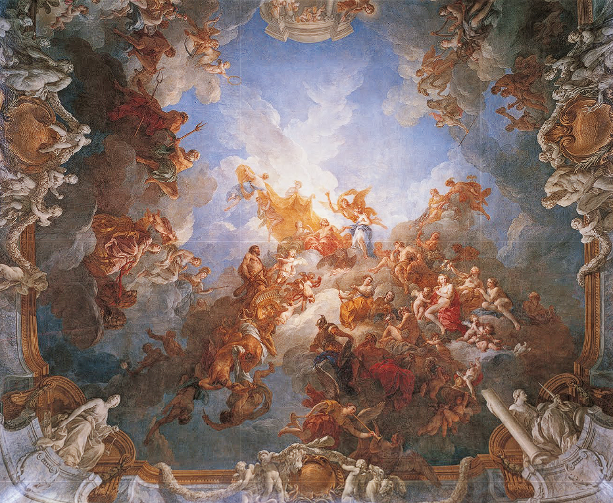
Source: Authors (2020)
Caption: Captions should be placed below the figures.
Note: If the photo was taken by the authors themselves, indicate Source: Authors’ private collection (September 2017)
Important: Visually, what distinguishes a chart from a table is that the chart is enclosed on the sides, while the table is open. Tables and charts are best arranged on a single page; therefore, whenever possible, arrange the text to meet this requirement.
When this is not possible, the text may require some layout adjustments so that the title accompanies the figure, chart, or table, always positioned above it. See Chart 1.
Figure 1 – Figures must have their titles at the top
Column 1 | Column 2 | Column 3 | Column 4
Row 1 | Value 1 | Value 2 | Value 3
Row 2 | Value 4 | Value 5 | Value 6
Row 3 | Value 7 | Value 8 | Value 9
Row 4 | Value 10 | Value 11 | Value 12
Row 5 | Value 13 | Value 14 | Value 15
Source: Table sources should be listed at the bottom. When presenting data generated by the research, indicate: Authors’ organization.
Table 1 – Tables must have their titles at the top
Column 1 | Column 2 | Column 3 | Column 4
Row 1 | Value 1 | Value 2 | Value 3
Row 2 | Value 4 | Value 5 | Value 6
Row 3 | Value 7 | Value 8 | Value 9
Row 4 | Value 10 | Value 11 | Value 12
Row 5 | Value 13 | Value 14 | Value 15
Source: Sources for tables should be listed at the bottom. When reproduced in full, cite as: Source: Last Name (year)

3 Final Considerations
Text body with section content in Open Sans 12 font, 1.5 line spacing, paragraphs with 1.25-inch indentation. Continuation of text body with section content in Open Sans 12 font, 1.5 line spacing, paragraphs with 1.25-inch indentation. Continuation of the text with section content in Open Sans 12 font, 1.5 line spacing, paragraphs indented 1.25.

Acknowledgments [if any]
Write your acknowledgments here, if any.

References
References must be listed in alphabetical order, using Open Sans font size 12, single spacing, no first-line indentation, with 12 pt spacing after each entry, following these guidelines:
Book: LAST NAME of the author, abbreviated first names. Title of the work: subtitle. Edition number. Place of publication: Publisher, year of publication. All are listed, separated by semicolons. English last names preceded by Mac or Mc remain in the same form. The expression et al. will be used only in the text for more than three authors. In references, it is recommended that authorship be cited in full, except when there are a large number of authors.
BASBAUM, R. Manual do artista-etc. Porto Alegre: UFRGS Press, 2021.
BRITO, R. Neoconcretism: Vertex and Rupture of the Brazilian Constructive Project. In: AMARAL, A. (ed.). The Brazilian Constructive Project in Art: 1950–1962. São Paulo: Pinacoteca do Estado, 1977. pp. 23–37.
CAMARGO, M. A. A. R.; AMARAL, A. A. Art and technology: the poetics of Regina Silveira. Arte & Ensaios, Rio de Janeiro, no. 27, pp. 122–135, June 2014. Available at: https://revistas.ufrj.br/index.php/ae/article/view/2230. Accessed on: Oct. 15, 2023.
CHIARELLI, T. A modernism that came from the cold. In: GULLAR, F. et al. Aracy Amaral: a life ahead of her time. São Paulo: Institute of Contemporary Art, 2022. pp. 15–25.
COUTO, M. A. S. Arthur Bispo do Rosário: the poetics of delirium. 2007. 215 p. Thesis (Ph.D. in Visual Arts) – School of Fine Arts, Federal University of Rio de Janeiro, Rio de Janeiro, 2007.
DIDI-HUBERMAN, G. Facing Time: Art History and the Anachronism of Images. Belo Horizonte: UFMG Press, 2015.
FABRIS, A. The Challenge of the Gaze: Photography and Visual Arts in the Modern Period. Projeto História, São Paulo, vol. 36, pp. 105–127, Apr. 2008. Available at: https://revistas.pucsp.br/index.php/revph/article/view/1864. Accessed on: Oct. 15, 2023.
FERREIRA, G.; MELLO, C. (Eds.). Lygia Clark: from work to event. São Paulo: Editora UFRJ / Editora SESC SP, 2006.
FREITAS, L. G. Photography as document and as art in the 19th century. In: 25th INTERNATIONAL COLLOQUIUM ON ART HISTORY, 2019, Porto Alegre. Proceedings [...] Porto Alegre: UFRGS Institute of Arts, 2019. pp. 432–445.
MARTINS, C. V. The painting of Beatriz Milhazes: procedures and patterns. 2010. 180 p. Thesis (Master’s in Visual Arts) – Institute of Arts, State University of Campinas, Campinas, 2010.
MESQUITA, A. Insertions in anthropological circuits: the exhibition as an essay. In: NAVAS, A.; MESQUITA, A. (eds.). On the Edge: Fredric Jameson and Critical Art. Madrid: Brumaria, 2019. pp. 178–199.
OSTROWER, F. Creativity and Creative Processes. 30th ed. Petrópolis: Vozes, 2013.
REZENDE, R. S. Curatorship as an artistic practice: the case of the 27th São Paulo Biennial. In: MEETING OF THE NATIONAL ASSOCIATION OF RESEARCHERS IN THE VISUAL ARTS, 22nd, 2013, Belo Horizonte. Proceedings [...] Belo Horizonte: ANPAP, 2013. pp. 1205–1217.
SANTOS, P. J. R. Mário Pedrosa’s Art Criticism and the Formation of the Arts System in Brazil. 2015. 290 p. Thesis (Ph.D. in Social History) – Faculty of Philosophy, Letters, and Human Sciences, University of São Paulo, São Paulo, 2015.
ZIELINSKY, M. Toward a Media Ecology in Art and Activism. Revista Gama, Lisbon, vol. 6, no. 2, pp. 60–71, July–Dec. 2018. Available at: https://revistagama.pt/edicao/6-2/. Accessed on: Oct. 15, 2023. DOI 10.0000/ggg.v6i2.12345.

1 – Author’s full name:
Title,
ORCID link and email:
Contribution (CRediT):
2 – Author’s full name:
Title
ORCID link and email:
Contribution (CRediT):
3 – Example of name
Visual Artist, Ph.D. in Visual Arts
https://orcid.org/0000-0000-0000-0000 • emailexample@ufsm.com
Contribution (CRediT):

How to cite this article
AUTHORSHIP. Article title. Expressão, Santa Maria, vol. xx, n. xx, 20XX. DOI 10.5902/2179460Xxxxxx. Available at: https://doi.org/10.5902/2179460Xxxxxx.

Example of a footnote.

